soen POE part 3

Software Engineering

Varsity College – Cape Town

BCAD

**Table of Contents**

Question 1 2

Part 1 Improvements: 2

Part 2 Improvements: 2

Question 2 3

Donation 5

Joining The Organization 6

Extras 10

Self-Evaluation: 16

References 17

Prototype 1 : Opening Top Page 3

Prototype 2 : Opening second page. 3

Prototype 3 : Opening Third Page 3

Prototype 4 : Choosing the Donation Money 5

Prototype 5 : Checkout Donation Money 5

Prototype 6 : Intro of Join Organization 6

Prototype 7 : Reg for Volunteer/Supporter Pic 1 7

Prototype 8 : Reg for Volunteer/Supporter Pic 2 7

Prototype 9 : Event Page 1 8

Prototype 10 : Event Page 2 9

Prototype 11 : Event one Info 10

Prototype 12 : Mission and Vision of Organization 11

Prototype 13 : Article 1 12

Prototype 14 : Article 2 12

Prototype 15 : Article 3 12

Prototype 16 : Article 1 info 13

Prototype 17 : Facts about Organization one 14

Prototype 18 : Facts about Organization 2 14

Prototype 19 : Facts About Organization 3 14

Prototype 20 : Contacts Page 15

Prototype 21: Emails 15

# Question 1

## Part 1 Improvements:

Reflecting on the feedback I received, I realize that my introduction fell short in a few key areas. While I did mention the Agile approach, I failed to clearly connect it to the non-profit’s mission of saving trees. I also touched on the scope of the project but didn’t delve into the specifics of the website’s functionalities. Furthermore, I didn’t adequately explain why the Agile approach is beneficial to my project.

Recognizing these shortcomings, I’ve made several revisions. I’ve emphasized the benefits of the Agile approach, detailing how its iterative nature and flexibility will aid in the successful execution of the project and align with the dynamic needs of the non-profit organization.

I’ve also expanded on the scope of the project, providing a more detailed overview of the website’s functionalities. This includes how each feature will contribute to the non-profit’s mission and enhance user experience.

These changes, I believe, have strengthened the introduction by providing a clearer, more comprehensive overview of the project, its alignment with the non-profit’s mission, and the benefits of the chosen development approach.

## Part 2 Improvements:

In the second part of my project, I selected the Model-View-Controller (MVC) pattern based on feedback. However, my initial explanation of the MVC pattern was not comprehensive enough, as I only provided a superficial overview without exploring into the core aspects of the MVC pattern. This resulted in a loss of marks.

To rectify this, I have now provided an in-depth explanation of the components that constitute the MVC pattern. I have elaborated on the roles and interactions of the Model, View, and Controller components, and how they contribute to the overall functionality of the application.

In the class diagram, I previously overlooked the inclusion of communication and inheritance. I had failed to specify the verb relationships between tables and did not implement inheritance where it was required. To address these issues, I have now explained the relationships between linked tables, enhancing the clarity of communication in the diagram.

For the implementation of inheritance, I have created a relationship between the ‘Trees’ and ‘Events’ classes, linking them to the ‘Program’ class. This addition demonstrates the hierarchical relationship and shared attributes between these classes, effectively implementing inheritance in the class diagram.



I am confident that these revisions have addressed the shortcomings in the first and second part of my project, where I provide more reasonable info on introduction and scope of a project and for part 2 providing a more thorough and accurate representation of the MVC pattern and class relationships in my software solution.

# Question 2

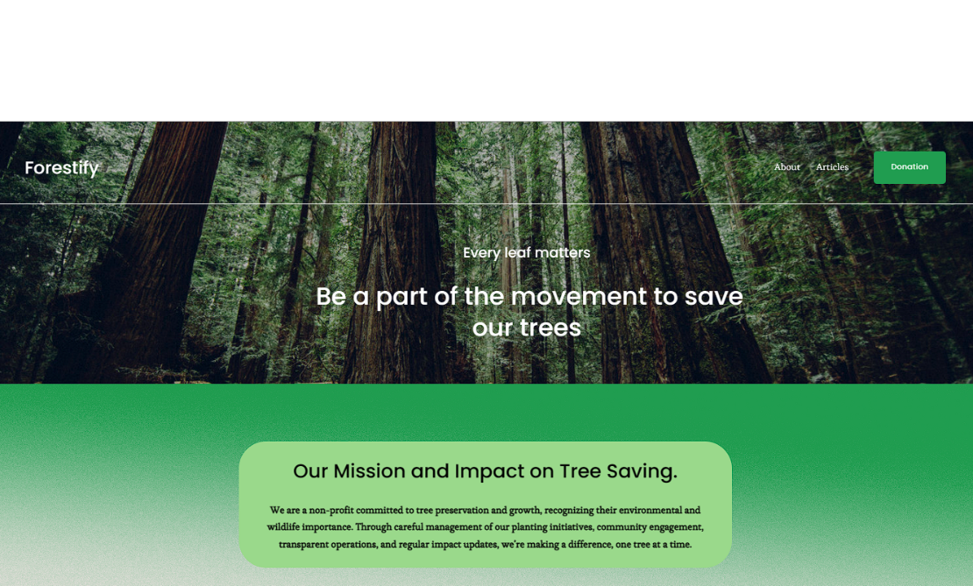

Prototype : Opening Top Page

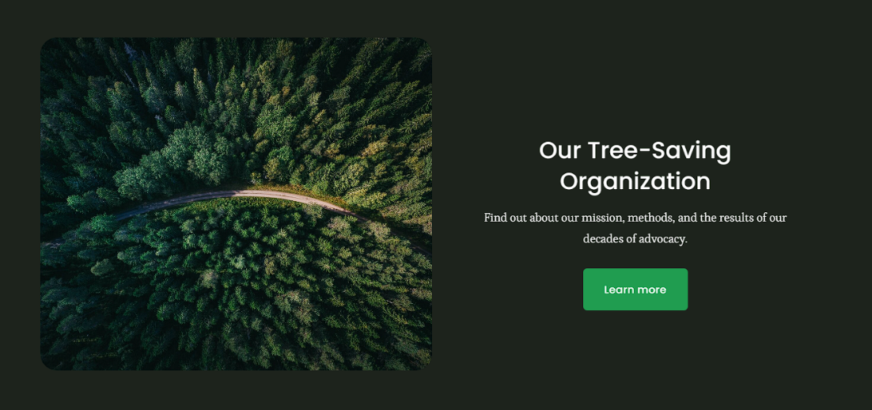

Prototype : Opening second page.

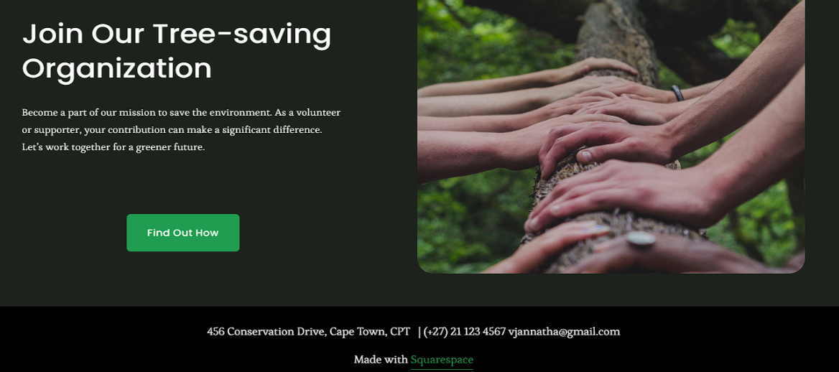

Prototype : Opening Third Page

The website of the tree-saving organization is split into three main parts: the ‘Opening Top Page’, the ‘Opening Second Page’, and the ‘Opening Third Page’.

The ‘Opening Top Page’ is like a welcome mat. It shows the organization’s slogan and has a button for donations. If you click on the donation button, you go straight to a page where you can donate money.

The ‘Opening Second Page’ tells you more about the organization. It talks about their vision, mission, and goals. This part helps users understand what the organization wants to do and how they help the environment.

The ‘Opening Third Page’ is for users who want to get involved with the organization. It tells you how to support or volunteer for the organization. There’s a button that takes you to a page with all the details about how to join. This design makes the website easy to use and encourages people to help out with the organization’s work to save trees.

I will be discussing more depth in coming screenshots.

Donation



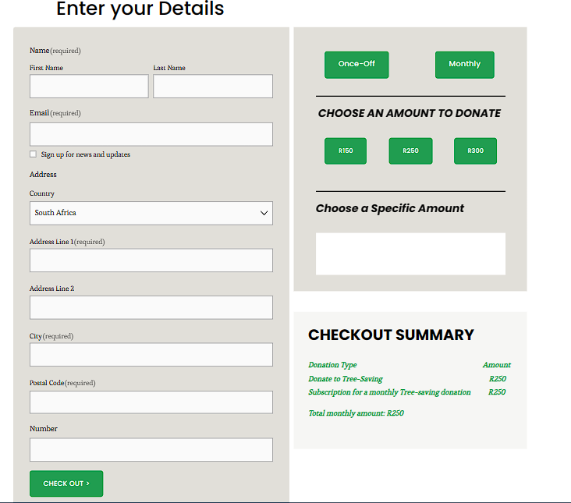



Prototype : Choosing the Donation Money

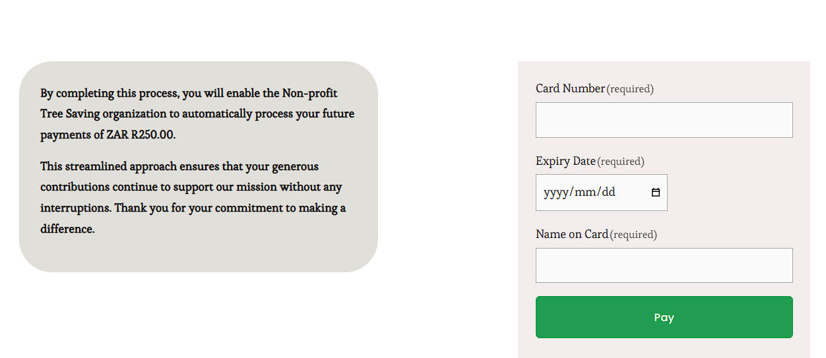

Prototype : Checkout Donation Money

When users go to the ‘Donation’ page, they see a form that’s easy to fill out. This form asks for their details and lets them pick how they want to donate. They can choose to give money just once or every month. They can also decide how much they want to donate. For example, let’s say a user decides to donate R250 every month. This amount then shows up under the ‘Checkout Summary’, so users can see what they’re about to donate.

To move on, users just have to click the ‘Check out’ button. This takes them to the ‘Checkout Donation Money’ page. This page is very secure and asks users to give their banking details. After they put in this information, they can start the payment process by clicking the ‘Pay’ button.

This sends an automatic email to the user. When the user says okay to this email, the donation process starts. After the payment goes through, the user gets a proof of payment. A copy of this proof is also saved in the tree-saving organization’s database. This whole process makes sure donating is safe, clear, and easy for all users.

## Joining The Organization

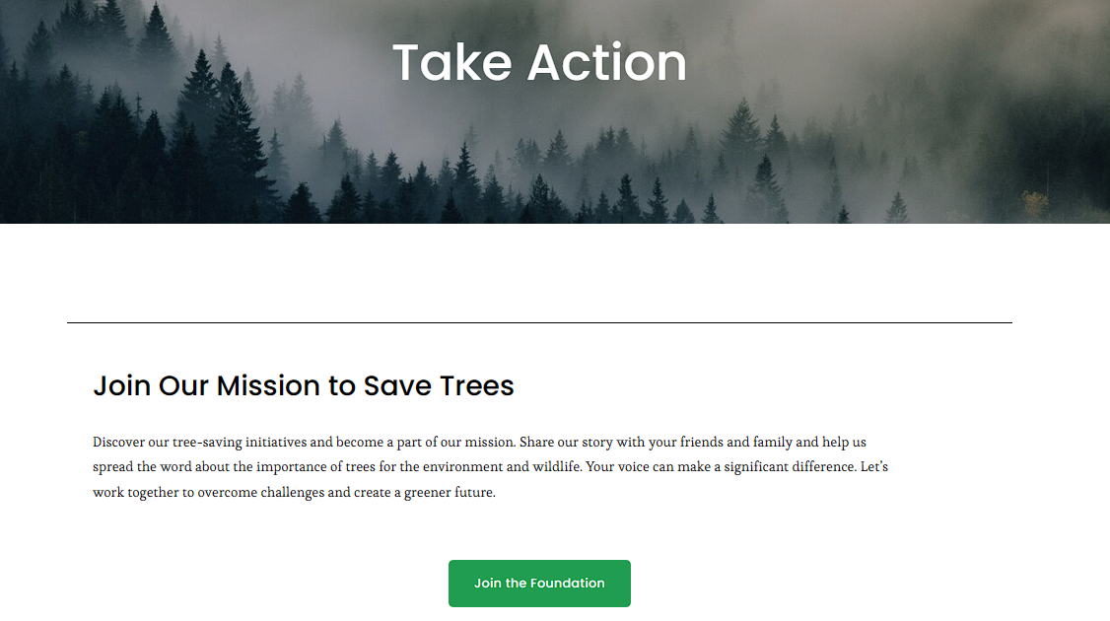

Prototype : Intro of Join Organization

This page, accessible from the ‘Opening Third Page’, presents an opportunity for users interested in joining the organization. Upon clicking the button, users are directed to this page, which provides further information and steps on how to become a part of the organization.

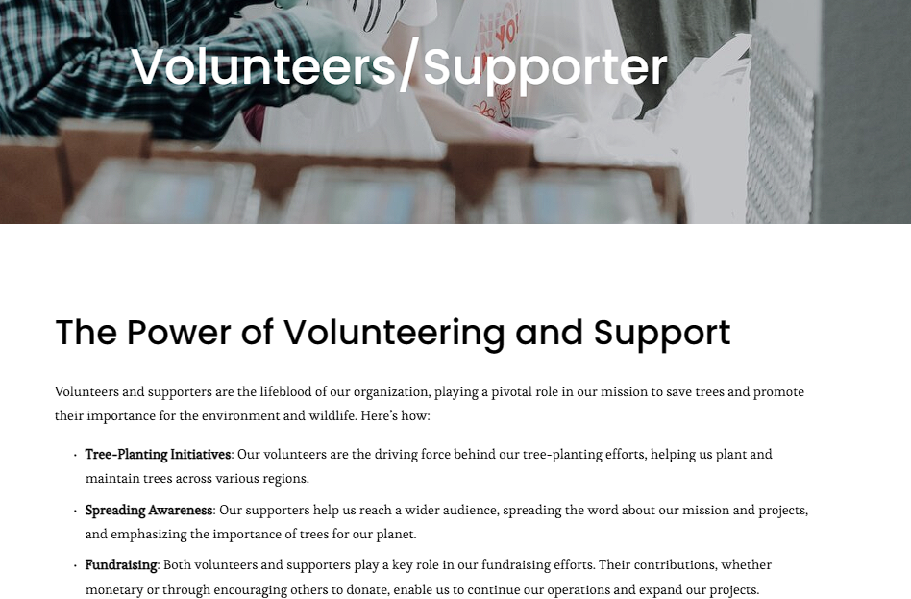

Prototype : Reg for Volunteer/Supporter Pic 1

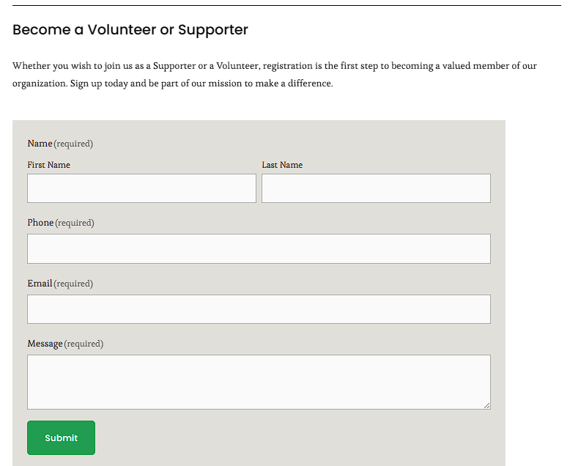

Prototype : Reg for Volunteer/Supporter Pic 2

The ‘Reg for Volunteer/Supporter Pic 1 and 2’ forms are part of a dedicated page, meticulously designed for those users who are inspired to join the non-profit organization as supporters or volunteers. This page serves as a comprehensive guide, shedding light on the crucial role that volunteers and supporters play in the successful functioning of our organization. It provides a detailed outline of their potential contributions, painting a vivid picture of the impact they can make.

After understanding the importance of their role, users are invited to become a part of our organization by registering themselves. This process is made simple and user-friendly, requiring them to provide their basic details in the registration form.

Upon clicking the ‘Submit’ button, an automated system swings into action, sending them an email notification. This email contains the organization’s terms and conditions, ensuring transparency about our policies and expectations.

Once users review and accept these conditions, they are warmly welcomed into our organization, officially becoming members. This entire process, from information to registration, has been designed keeping user convenience and engagement in mind, making it a seamless and rewarding experience.

After that it will take to this page called ‘Events Page’.  
  
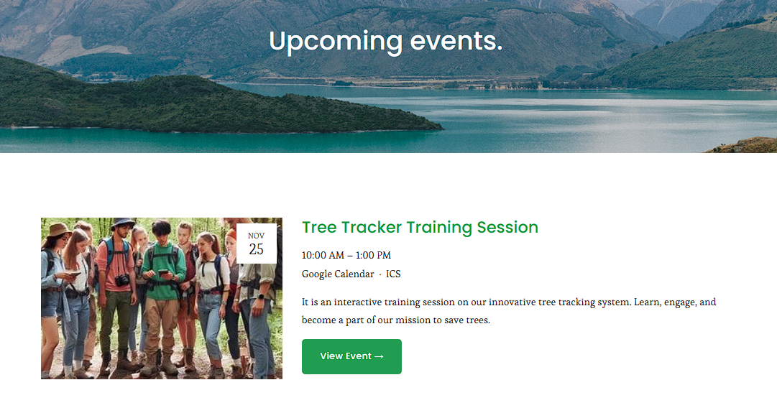

Prototype : Event Page 1

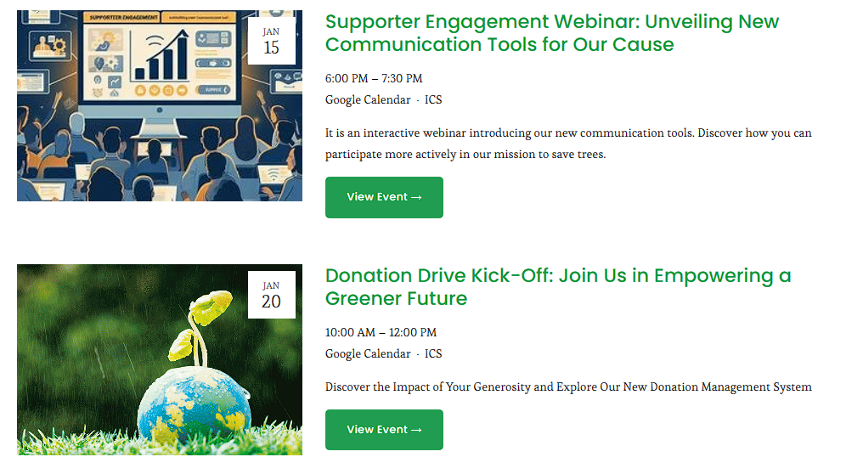

Prototype : Event Page 2

The ‘Event Page 1 and 2’ forms a unified page, exclusively designed for our registered volunteers and supporters. This page serves as a central hub, providing a wealth of information about upcoming events or projects. It offers a detailed breakdown of what roles and responsibilities the volunteers and supporters can expect to undertake, ensuring they are well-prepared and informed.

To ensure our volunteers and supporters are always in the loop, registered members receive timely email notifications about these upcoming events. These emails are thoughtfully crafted, providing a snapshot of the event while also including a direct link for those who wish to explore more.

Upon clicking this link, members are seamlessly directed to the event page. Here, they can access more detailed information about the event, including its purpose, agenda, and how they can contribute. This feature ensures that our volunteers and supporters have all the information they need at their fingertips, enhancing their experience and involvement with our organization. This page is a testament to our commitment to keep our volunteers and supporters engaged, informed, and appreciated.  
  
so, when they click ‘View Event’ Button.  
  
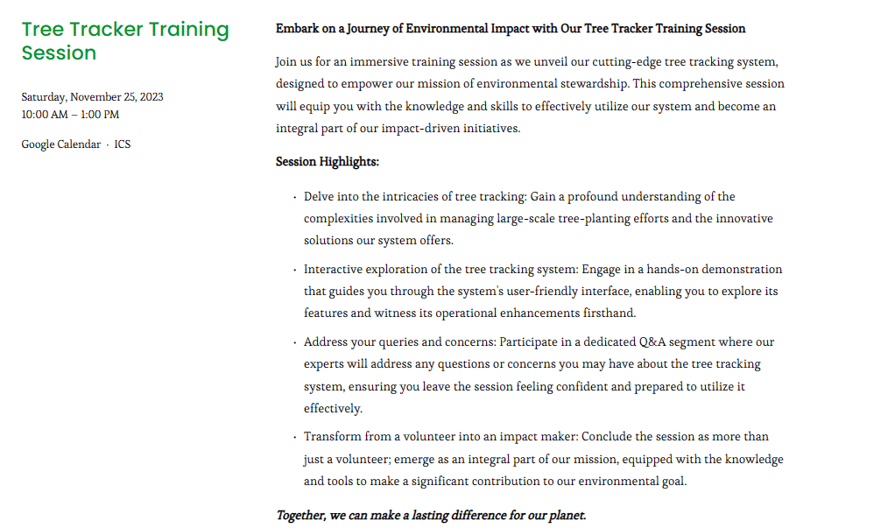

Prototype : Event one Info

This page serves as a comprehensive guide for volunteers and supporters, providing detailed information about the event they will be participating in. It outlines the various activities they will engage in to assist participants, ensuring they are well-prepared for their roles.

In addition to this, the page also includes essential logistical information such as the date and time of the event. The specific location of the event is disclosed upon arrival at a designated common area, adding an element of anticipation and excitement to the experience.

This process ensures that our volunteers and supporters are not only well-informed but also feel a part of the event, enhancing their overall experience. This same procedure is applied to all other events, ensuring a consistent and efficient experience for all our volunteers and supporters.

In essence, this page is a testament to our commitment to provide our volunteers and supporters with all the information they need, ensuring they feel valued, prepared, and excited for the event.

Extras  
This is a guide intended solely for regular users, providing an overview of the features available on this website.

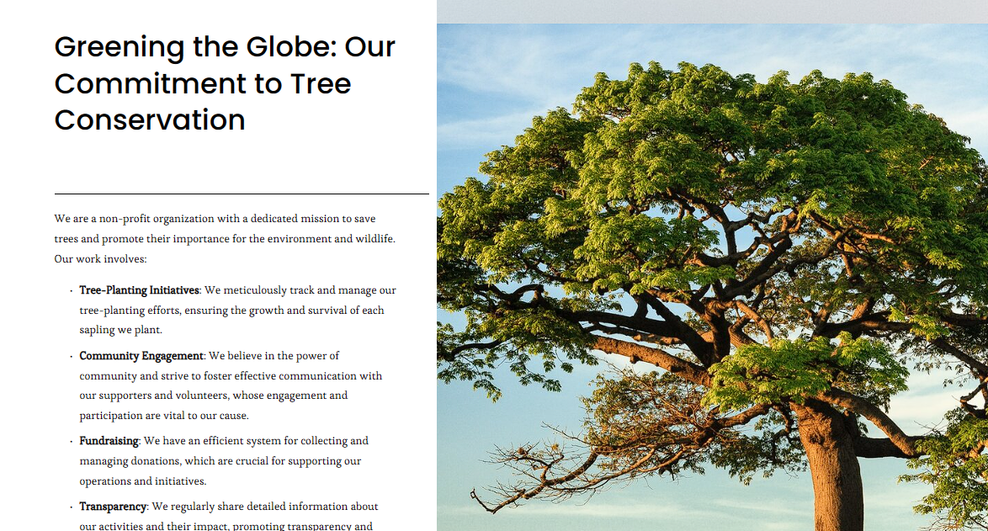

Prototype : Mission and Vision of Organization

This image is a key feature of the “Opening Second Page”. When a regular user interacts with our site and clicks the button, they are seamlessly directed to this page. This page is a vital component of our non-profit organization, embodying our mission and vision that are the pillars of our work.

The primary objective of this webpage is to provide users with a comprehensive understanding of our organization’s journey and objectives. It serves as a window into the heart of our operations, allowing users to gain insights into the inner workings of our non-profit organization.

By exploring our page, users can enhance their knowledge and appreciation of our efforts. This understanding fosters a deeper connection between us and our audience, encouraging their active participation in our cause. In essence, this page is a testament to our commitment to transparency, engagement, and fostering a sense of community among our supporters.

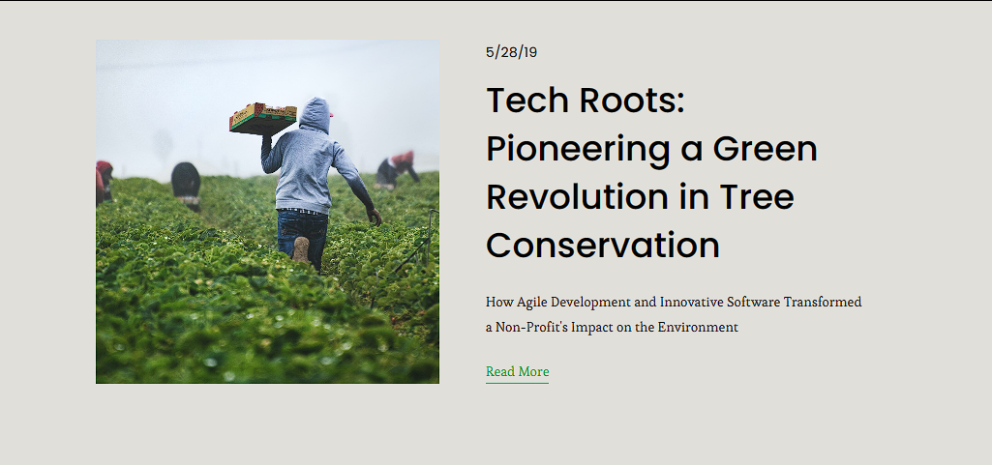

Prototype : Article 1

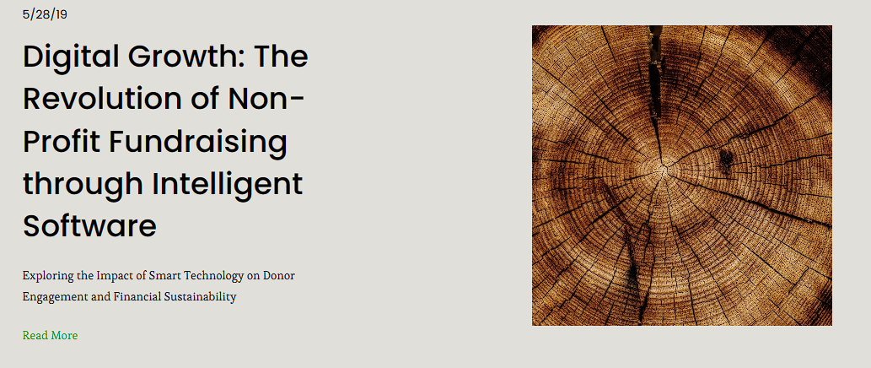

Prototype : Article 2

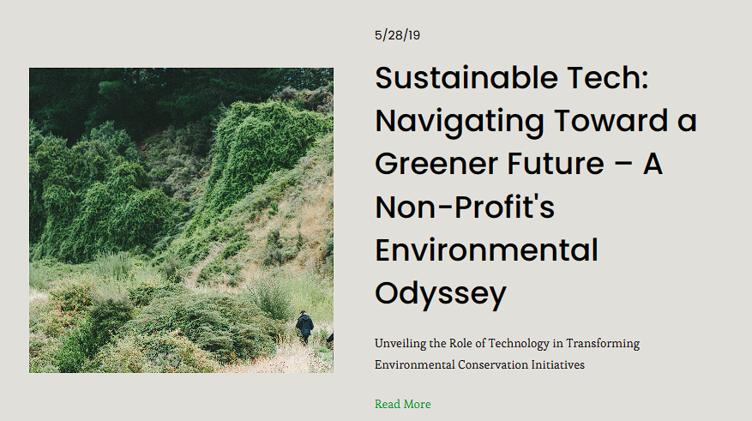

Prototype : Article 3

On the ‘Opening Top Page’, there’s a tab called ‘Articles’. When a user clicks on this, they go to a page with three special articles. These articles are made to teach users about new technologies that help the environment and other cool ideas.

These articles do two things. First, they give information to the users about the newest things in environmental technology. Second, they give a little hint about what the tree-saving organization is planning to do next. They suggest that the organization is going to use these new ideas in their future projects.

So, these articles are not just a way to learn new things. They also let users know what the organization is planning to do in the future. This keeps the users interested and lets them know that the organization is serious about helping the environment.

It is also indication on how this organization implementing new concepts in future and it helps to reach out to many users.

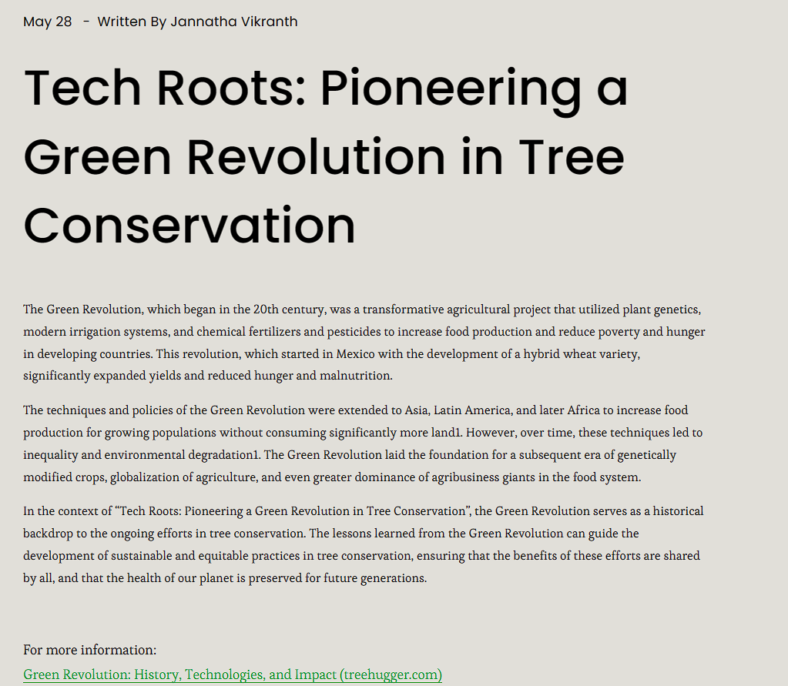

Prototype : Article 1 info

When a user clicks on the first article from ‘Article’ Section, they get to read about how the Green Revolution changed farming all over the world. The article talks about how we can use what we learned from this revolution to help save trees in a fair and sustainable way. It gives a good overview of the topic, so it’s easy for everyone to understand.

If someone wants to learn more about the topic, the article has a link to more information. This is great for users who want to learn about new ways to help the environment. This is how all the articles work, each one talks about a different topic. Whether it’s about how technology can help the environment or why sustainable practices are important, these articles have a lot of information. They teach the readers and inspire them to help make the future greener and more sustainable.

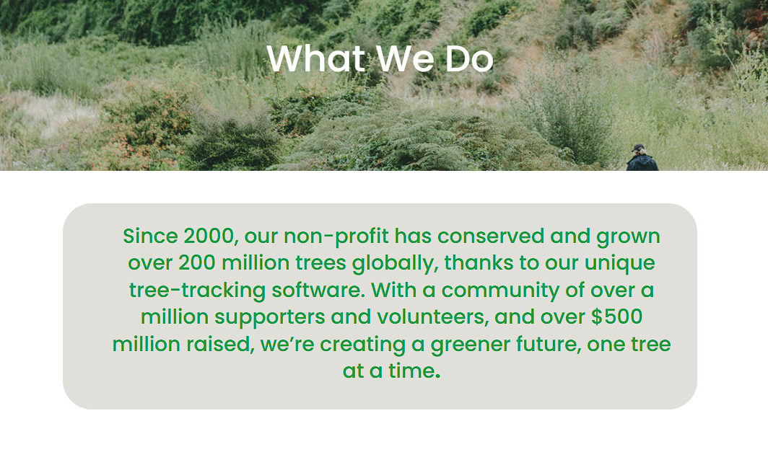

Prototype : Facts about Organization one

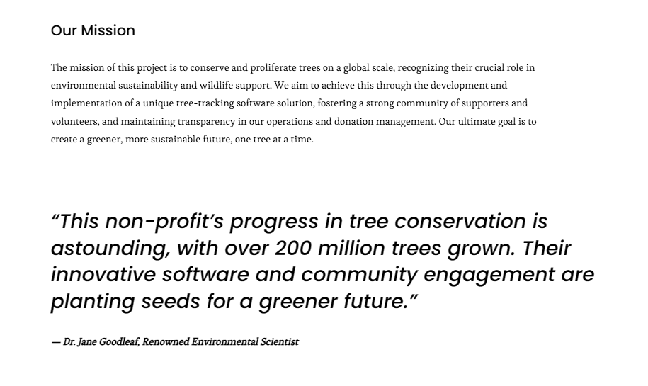

Prototype : Facts about Organization 2

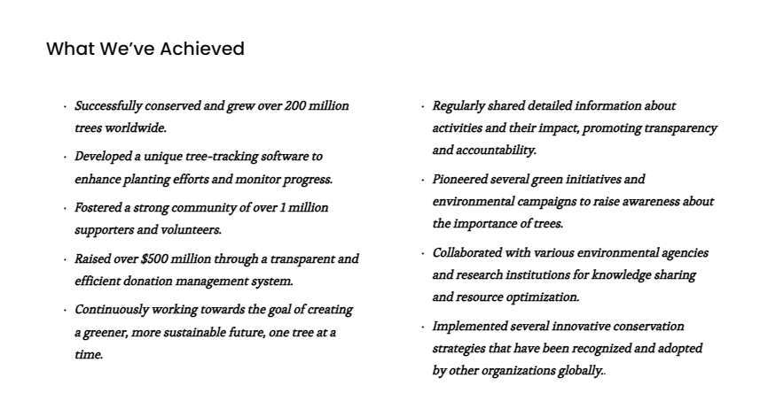

Prototype : Facts About Organization 3

The ‘Facts about Organization’ page is a place where you can learn a lot about our organization. You can get to it from the ‘Opening Top Page’ by clicking on the ‘About’ tab and then ‘What We Do’. This page tells you about our history, what we’ve done over the years, our mission, and what we’ve achieved so far.

This page is made to give you a lot of information about our organization. It’s really useful for people who want to understand our work and how we make a difference. It tells the story of our journey and shows how committed we are to our cause.

This page talks about how we started and what big things we’ve done. It shows how much we’ve grown and the impact we’ve made. It gives a clear and detailed look at our work, which helps build trust with our audience. Whether you’re thinking about volunteering, donating, or just interested in our cause, this page gives you a good look into what our organization is all about.

Lastly

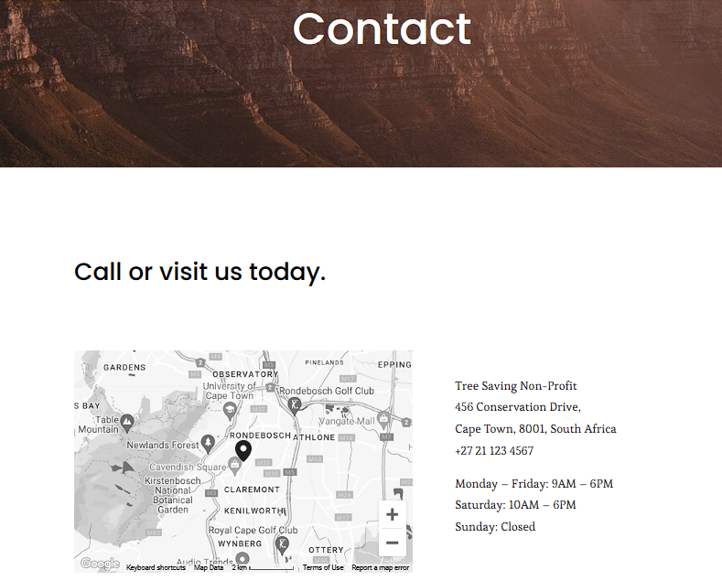

Prototype : Contacts Page

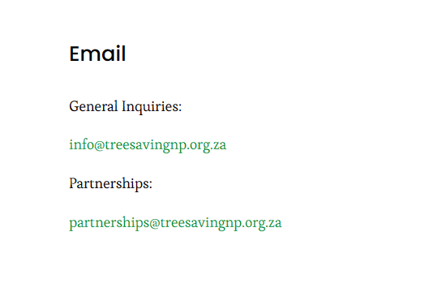

Prototype : Emails

The last picture from ‘Contact’ Page shows how to get in touch with the organization. It’s really important for people who want to talk to the organization or visit them. It has all the ways you can contact them, like where they are located and their email addresses.

This part of the website is made to make sure people can easily reach out to the organization if they have any questions, worries, or ideas. It shows that the organization wants to keep talking to its audience and make sure they feel heard.

Whether it’s a question about what the organization does, a worry about a certain project, or an idea for something new, this contact information makes sure everyone can be heard. It shows that the organization values feedback and wants to keep getting better. This contact information shows the organization’s promise to be open, involve everyone, and provide good customer service.

## Self-Evaluation:

Looking back at this project, I feel good about what I’ve learned. I decided to work on a project about saving trees because I really care about nature. This made the project fun and helped me understand why these kinds of organizations are so important.

I did some research on real non-profit organizations that help nature. This was interesting and taught me a lot about what they do. It also made me even more sure that protecting nature is important.

Creating a plan for a tree-saving website was a great part of this project. It let me use what I learned in a real way, which helped me understand things better. Plus, it felt good to do something that could help save trees, even if it’s just a small thing.

All in all, this project was a big learning experience for me. I learned a lot of useful things and it made me appreciate nature even more. I’m excited to use what I’ve learned in the future.

References:

I apply the ‘Square Space’ platform for developing prototype wireframes. However, due to the private nature of these wireframes and the associated costs, I’m unable to provide a public link. Please note that ‘Square Space’ is a robust tool that aids in the effective creation of these prototypes.